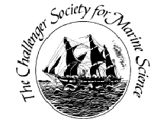
Challenger Society for Marine Science
Meetings Funds Request Form
The Challenger Society supports scientific meetings concerned with any aspect of marine science, as well as its Special Interest Groups. Support may be for the meeting as a whole, or directed to specific aims, such as promoting attendance of early career researchers, CSMS members or inviting a high profile speaker.
Please note that the lead convener must be a Challenger Member.
Further details about the Special Interest Groups are available on our website at: http://challenger-society.org.uk
Convenors:

Email of lead convener: | Membership number of lead convener:
Address: | Address for payment, if different:
Event:
Location: | Date:
Total Meeting Cost: | Requested funding:
We agree to write a report of the meeting
Justification:

Signature: | Date:
Notes: If the meeting is not a regular meeting of a Challenger Society Special Interest Group, a statement of justification for the award of funds should outline the subject and significance of the proposed meeting and indicate the total cost of the event. Recipients of Meetings funds from the Challenger Society are asked to provide a brief report of the event within two months, to be published in Ocean Wave or Ocean Challenge.

