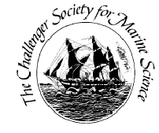
Challenger Society for Marine Science
Stepping Stones Research Bursary Application Form

- The Society cannot guarantee that an award will be made and this should not be assumed in applying for funding elsewhere.

- Deadlines for applications are: January 15th, April 15th, July 15th and October 15th

Please refer to the more detailed “Guide for Applicants” when completing this form, which can be found at http://www.challenger-society.org.uk

Name: | email:
Qualifications: MSc PhD Other; please specify:
Address:  Challenger Membership no.: | Address for payment, if different
Have you previously received a Stepping Stones research bursary? Yes No If yes please give the date of the award notification:
Evidence of recent research activity (200 words max.):

Evidence/statement of employment status:
Description of research activity applied for (200 words max.):
Breakdown of costs (see notes):

Benefit of research activity (200 words max.):

Referee’s statement of support:

Name of referee: Signature: Email:
Referee member of the Challenger Society? Yes No
I agree to write a report | Your submission date for report (must be a maximum of 3 months after the research activity):

Request received / / Cheque No.
w
Paid / / Amount
Paid by

Applicant Signature: | Date:
Please complete this form and return it to Dr. Sophie-Berenice Wilmes (s.wilmes@bangor.ac.uk).

