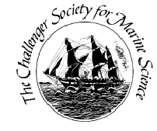
Challenger Society for Marine Science
Student Travel Award Report Form
Please complete this form as a Word Document ONLY and return it to Dr Sophie-Berenice Wilmes (s.wilmes@bangor.ac.uk).

Title of report/travel/event attended:

Awardee Name:

Institution:

Report: (750 words max)

Awardee Profile: (100 words max)

Twitter Feed: (140 characters max)

Year of travel/event:

Please attach max TWO photos or images upon email submission of this form.
Make them interesting for the viewer – they should summarise your experience of the travel and/or research collaboration / conference. Please submit a decent quality image, a blurry one of you in front of your poster does not look good on the website.

